[](https://hr365docs.github.io/docs/)

Table of Contents

Introduction 2

Home Page 2

**Self Review** 6

**Review** 7

**Summary and Plan** 8

**360 Feedback** 11

**Feedback Request** 11

**Received** 13

**Given** 13

**Action** 14

# Introduction

Performance Management 365 is an application that drives productivity and engagement of employees for outstanding business results with Performance Management 365 for SharePoint and Microsoft 365. Your teams drive your business. Quality reviews enhance your employee's performance. With HR365’s Performance Management 365Plus, you can have a 360-degree, continuous feedback system & 1:1 to evaluate employees with customized performance appraisal methods. Identify high performers and employees to be trained for desired results. Set goals gather feedback, continuous feedback, and review performance. Bridge the gap between where employees are and where they need to be.

# Home Page

On **Home Page** Users can check the appraisal cycle status and rate their own performance in self review and can request feedback.

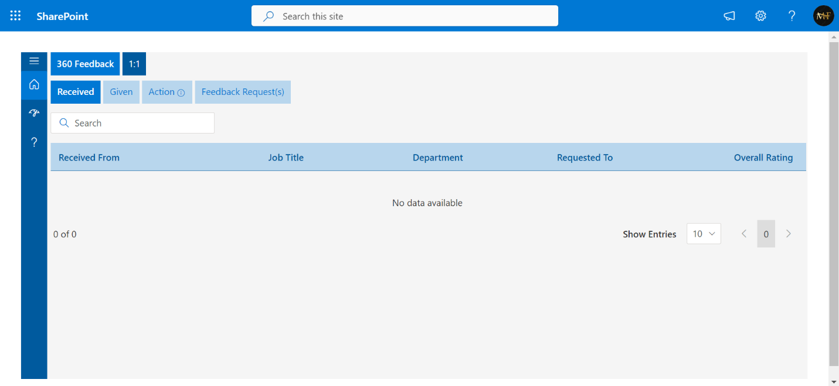

**My teams**: Appraisers can find their team members who have been in appraisals (called appraisees).

The employee review status column provides the status of self-review of the appraisee. Once the appraisee completes their self-review, the Employee Review status gets updated with the completed status, From the edit icon display in the action column - the appraiser could review by clicking on it.

**Self-Review**: Appraisee can do their self-review. When the appraisal cycle initiates, they find KRAs categories-wise and based on their job tiles. They can rate themselves along with comments and finally sign to submit.

**Additional reviews**: This feature is available to only Managers they can add an additional review to the appraisee

**360 feedbacks**: Under 360 feedback we provide 5 options Feedback Request, Action, Given Action, and Organization feedback.

**Feed request**

Request: This option is available to appraisees. From here they can request 360 feedback from the other company employee by clicking on the request button. All the requests are shown in the feedback request as shown below.

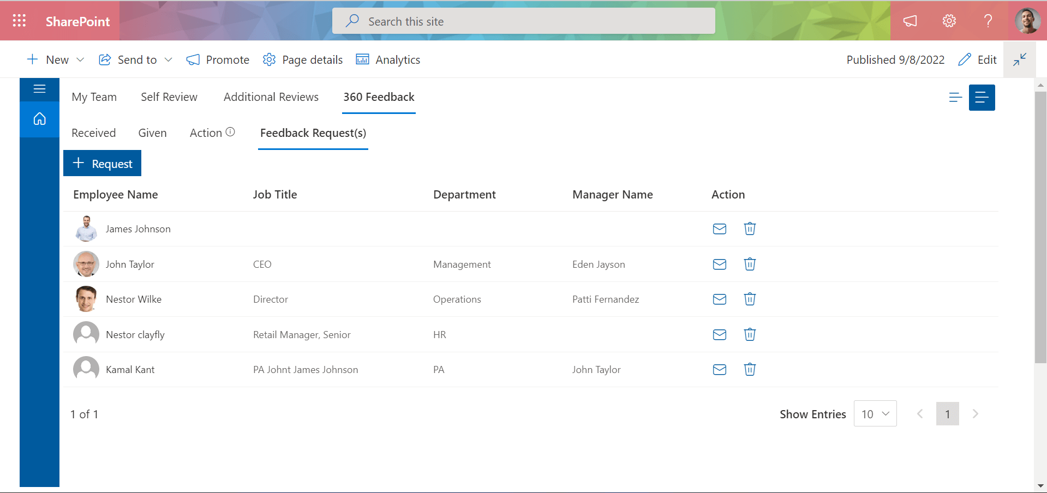

**Teams**: This option is available to Managers. From here they can send feedback requests on behalf of their reportee to their team (peers, reportee and manager).

Click on the team as shown in below, the page will open then select the team member or reportee, select the feedback requester check box and click on submit request button.

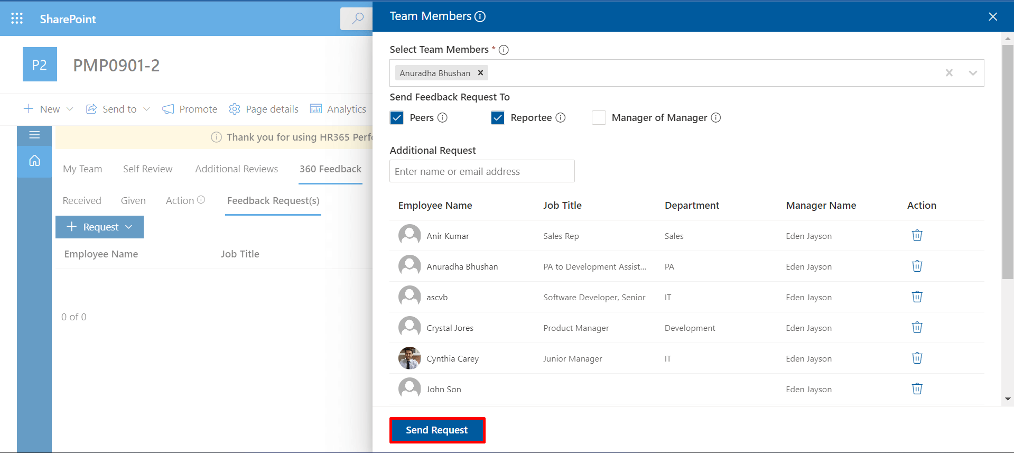

**Action**: From here a user can see all the 360 feedback requests requested by appraisees under the action. And they can provide feedback from action icon.

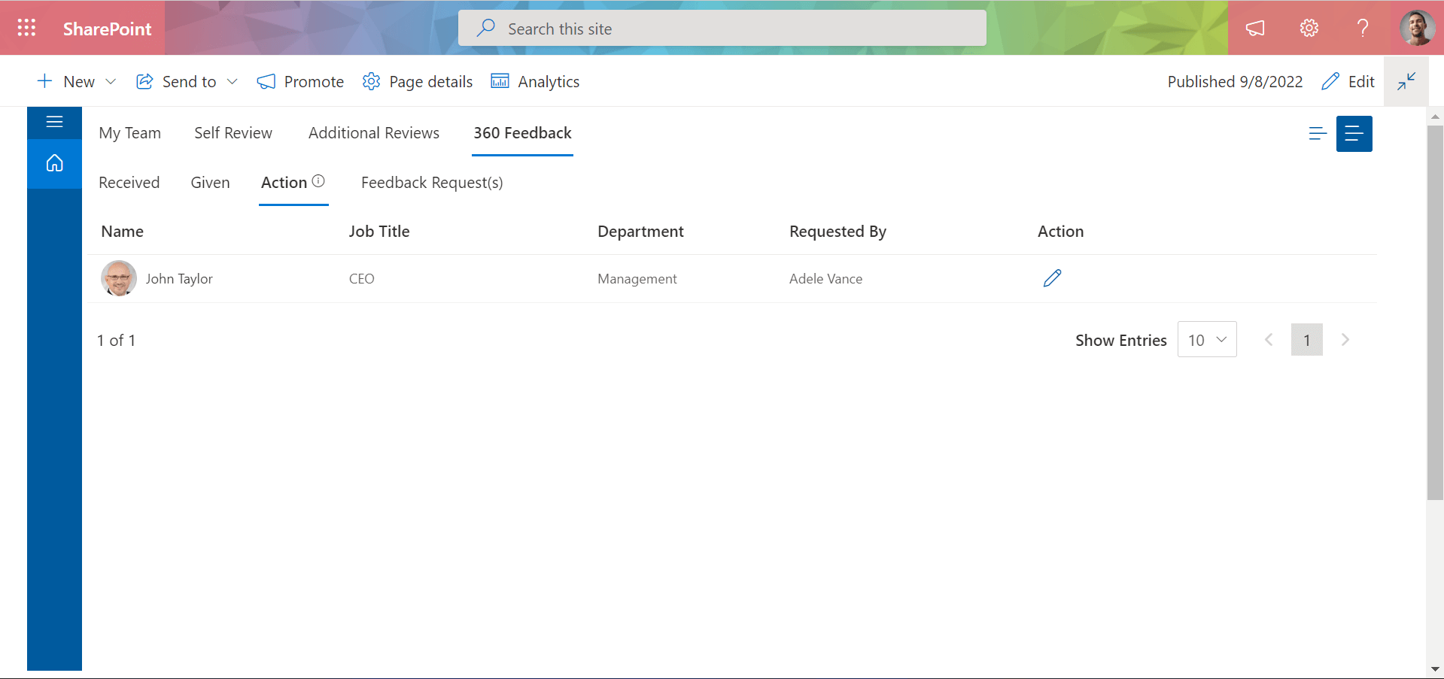

**Given**: From here user can find their given feedback on appraisee's requests.

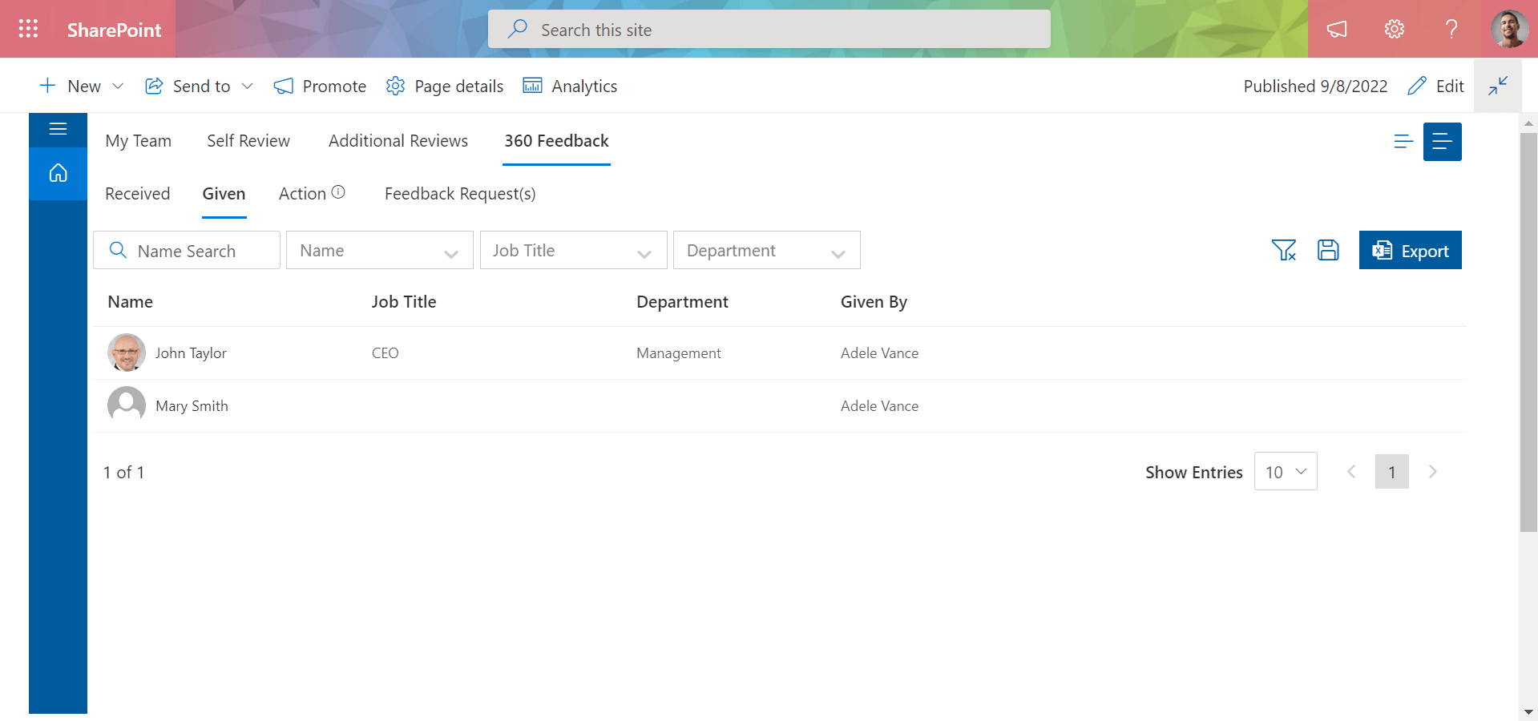

**Received**: From here appraisee can find feedbacks for which they requested.

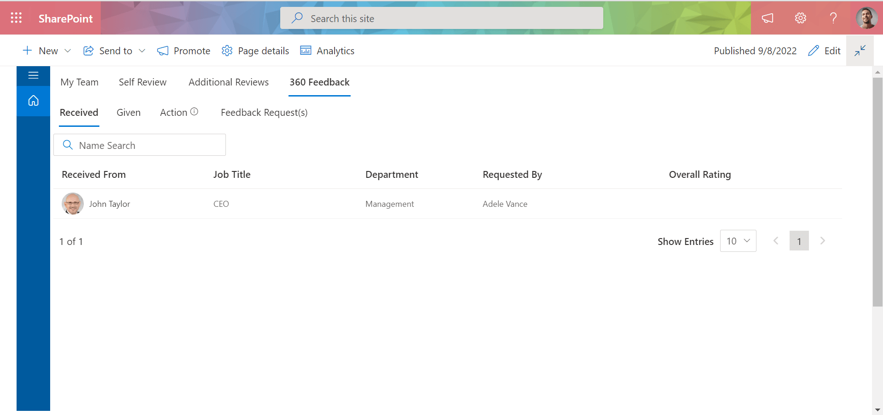

**Organization feedback**: This option is displayed only for the HR team. The user could select the departments, and individual employees of the selected department would receive a feedback request to review their manager or MoM based on the below selection with the start date of the review.

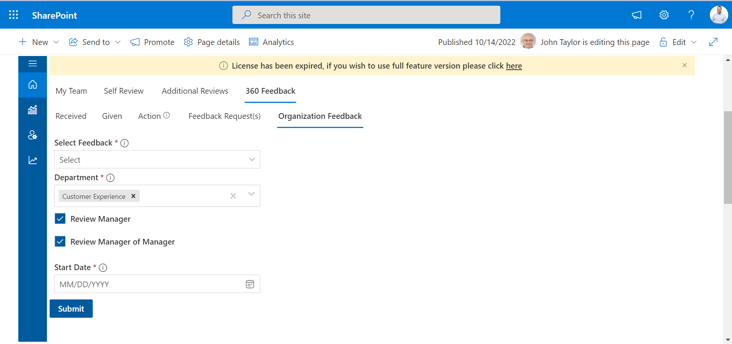

# **Self Review**

In **self-review**, the user can give himself a rating according to his performance and can review his rating.

1. Review
2. Summary and Plan

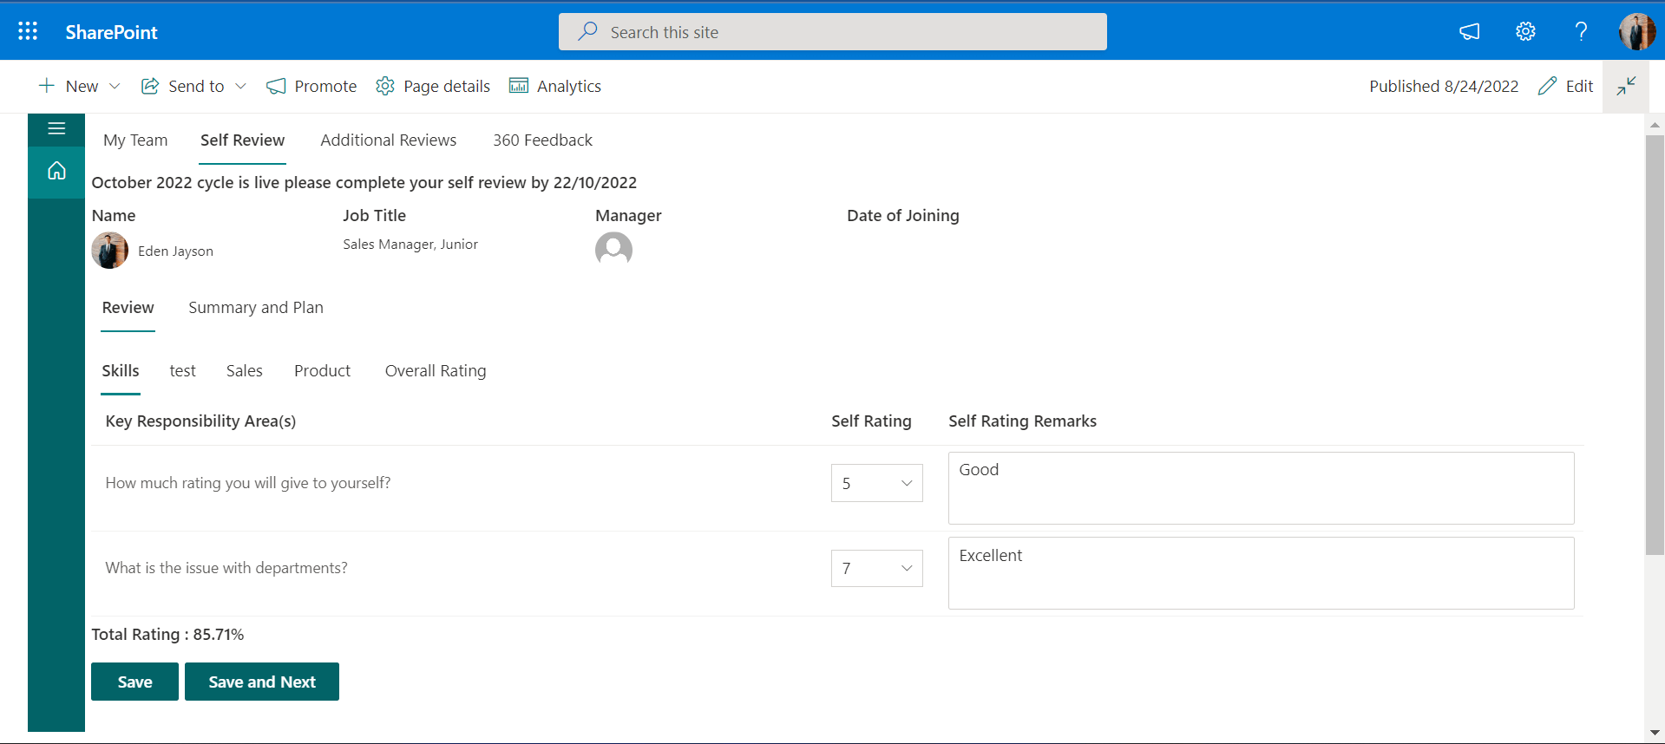

## **Review**

Inside the review, we have some different categories and inside some KRA(Key Responsibility Area), some questions are created by the admin for the user. In which the user can give himself a rating according to his performance, and finally, in the overall rating, the user can check his overall rating.

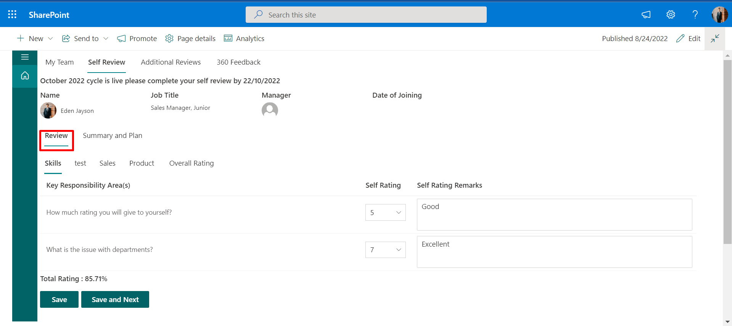

Skills,Product, Sales are different types of categories that are created by the admin for the user. There are some questions inside KRA(Key Responsibility Area) that were created by the admin. A user can give only a rating to himself through these questions and can also add self-rating remarks.

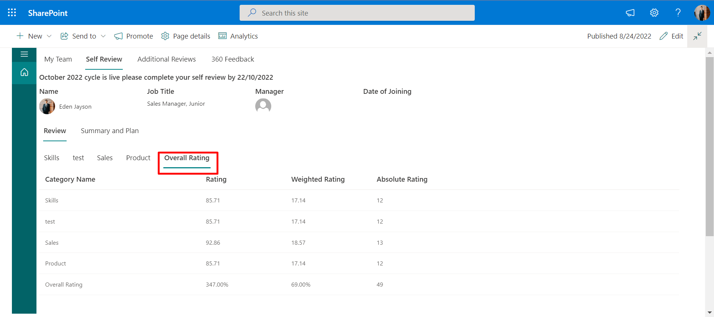

In the image Overall Rating, the user can check the overall self-rating in the form of Simple Rating, Weighted Rating, and Absolute Rating.

## **Summary and Plan**

**Summary and Plan** are like feedback, in which the user gives their feedback. Here the user gives feedback on their performance.

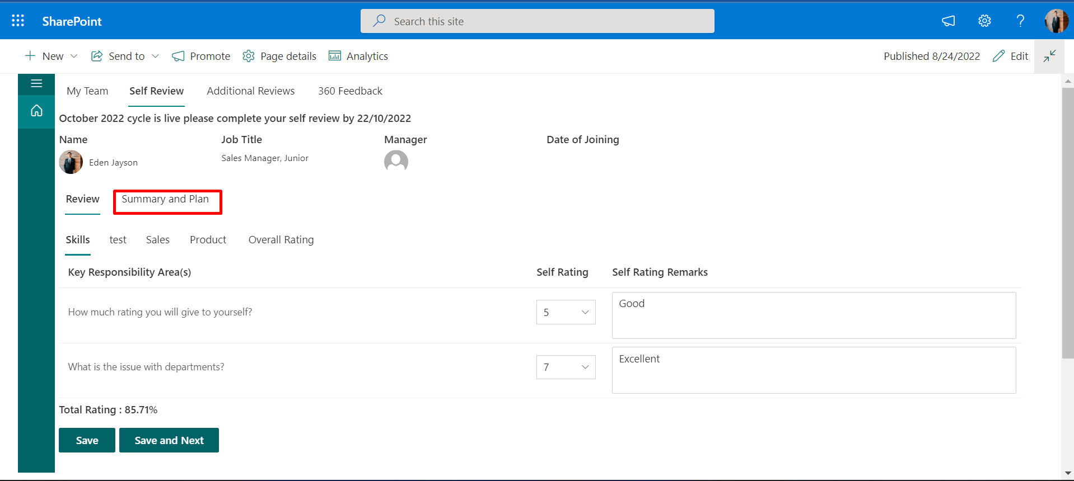

1. **Achievements:**  Here the user writes about what he/she did last year and what achievements he/she achieved. After that, click on the **Save and Next** buttons to move to the next tab.

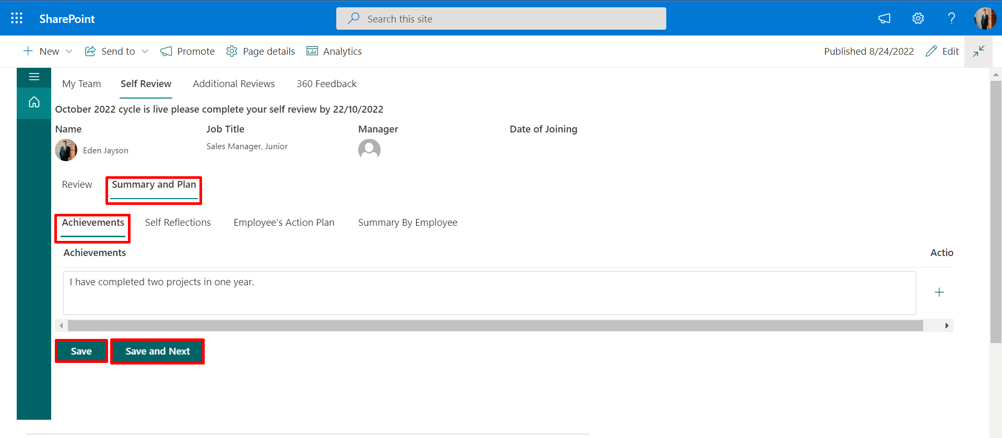

1. **Self Reflections:**    Here the user can write about their positive attributes and give a written view of their performance cycle. It involves their ratings, established goals, competencies, and overall performance.

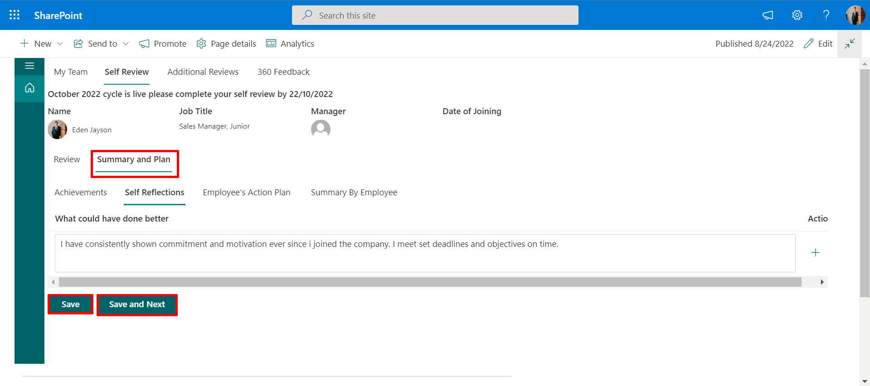

1. **Employee's Action Plan:**  Users can write about their plans, or what they intend to do for future tasks, in this section. which he/she will achieve the goal in the future. After that, click on the **Save and Next** buttons to move to the next tab.

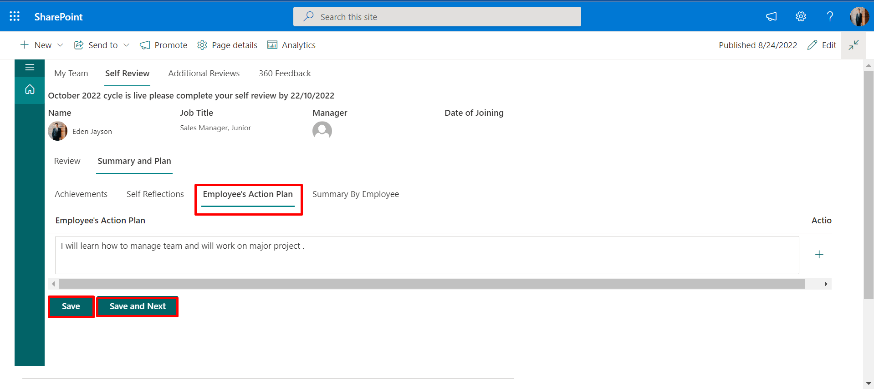

1. **Summary By Employee:**    Here the user can write about his overall performance, which means what he/she did in the past year and what he/she will do in the future, what he/she achieved in the past and what he will achieve in the future.

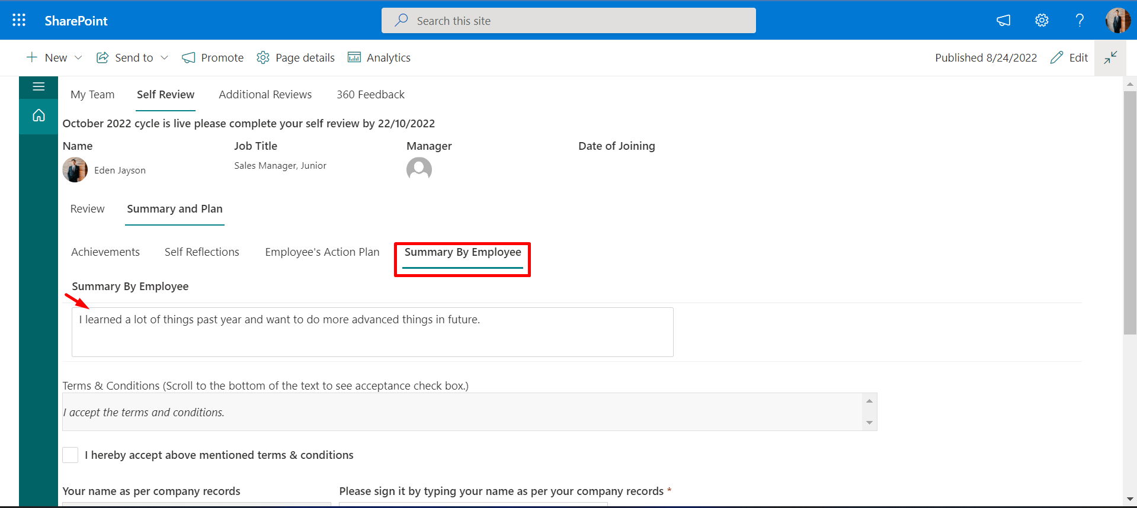

After completing the summary and plan, select the checkbox and sign it by typing your name, then click on the **Sign** button, same as in the below image.

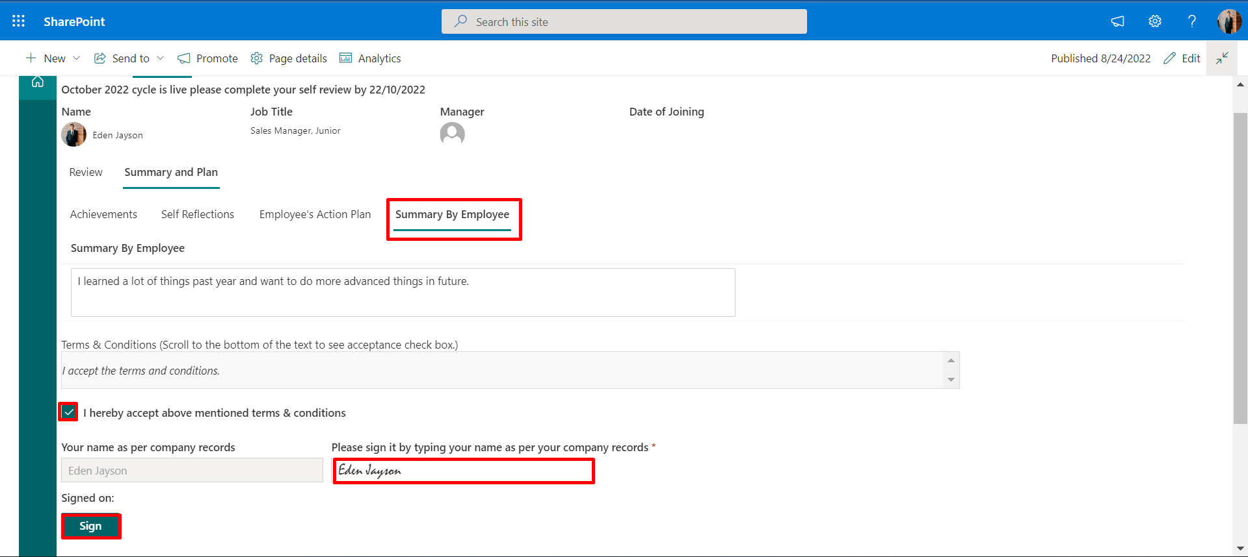

Your **self-review** has been successfully submitted, as shown in the image below.

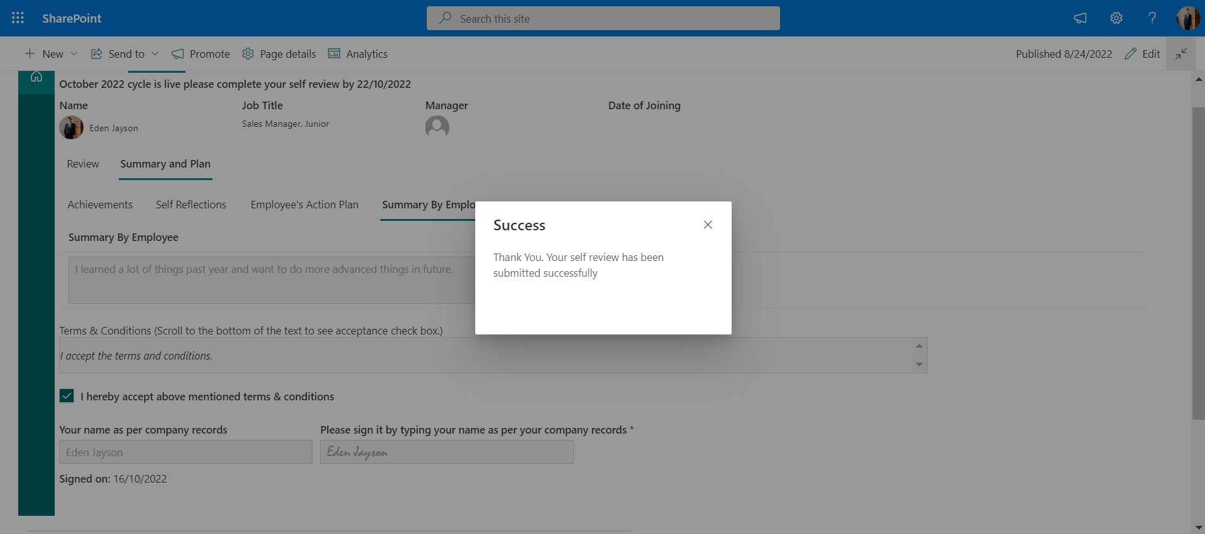

# **360 Feedback**

In 360 Feedback, the user can request feedback from the Admin, HR, and Manager and can also receive the request and perform an action on it. It is individual from the appraisal cycle.

1. Feedback Request
2. Received
3. Given
4. Action

## **Feedback Request**

In the Feedback Request, if you want your feedback from anyone then you can click on the Request button.

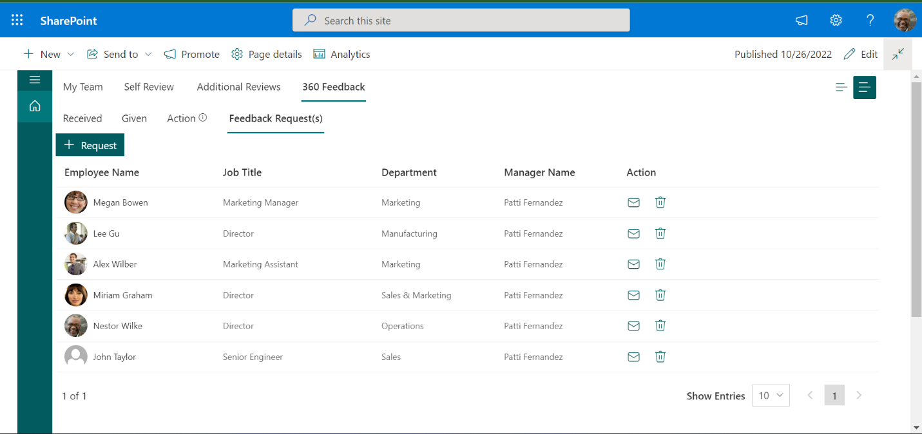

After clicking on the request button it will open a panel and in this panel select people as you want your feedback.

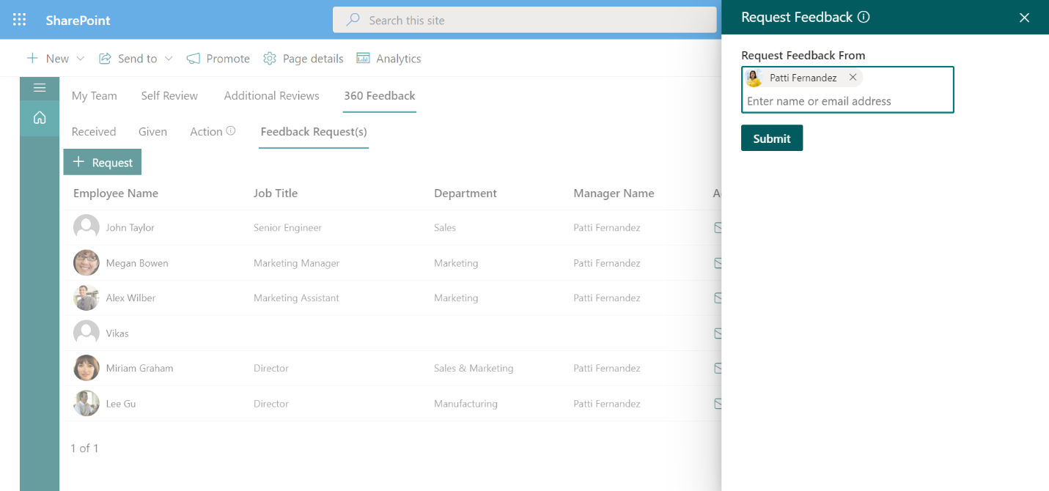

After clicking on the submit button, in the feedback request to whom we have sent the request for feedback, its details will be shown as shown in the image below.

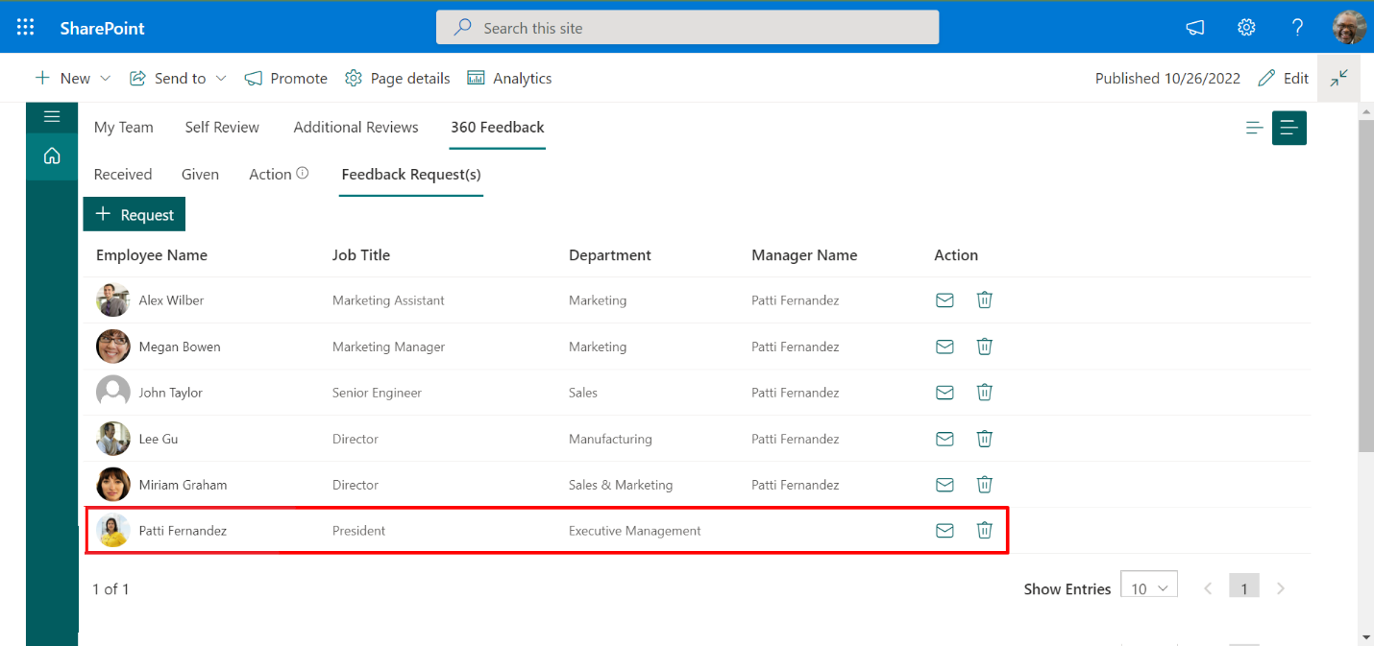

## **Received**

In the received user can check whether his feedback request has been received or not and by whom. The details of the person by whom the request has been received will be shown here as shown in the image below.

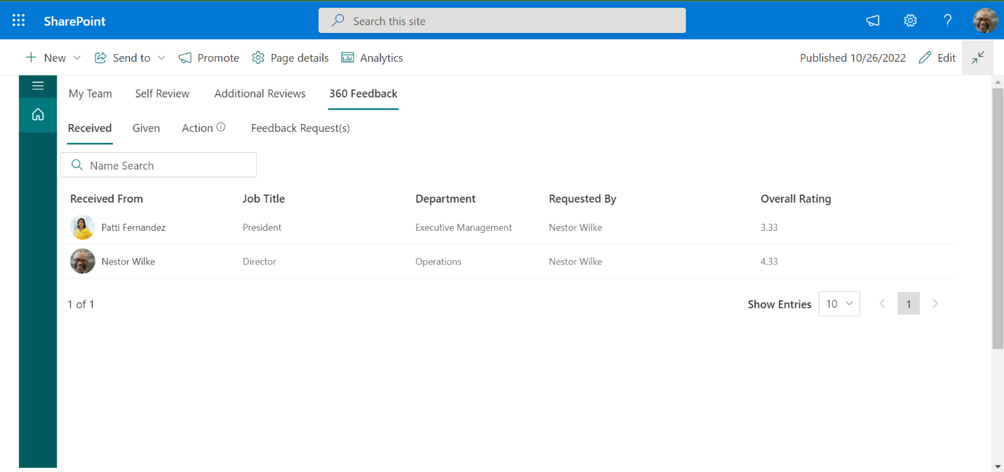

## **Given**

In the given, the user can check whether he has received any request for the feeder or not. If the user has received a request for feedback, it will be shown here as shown in the image.

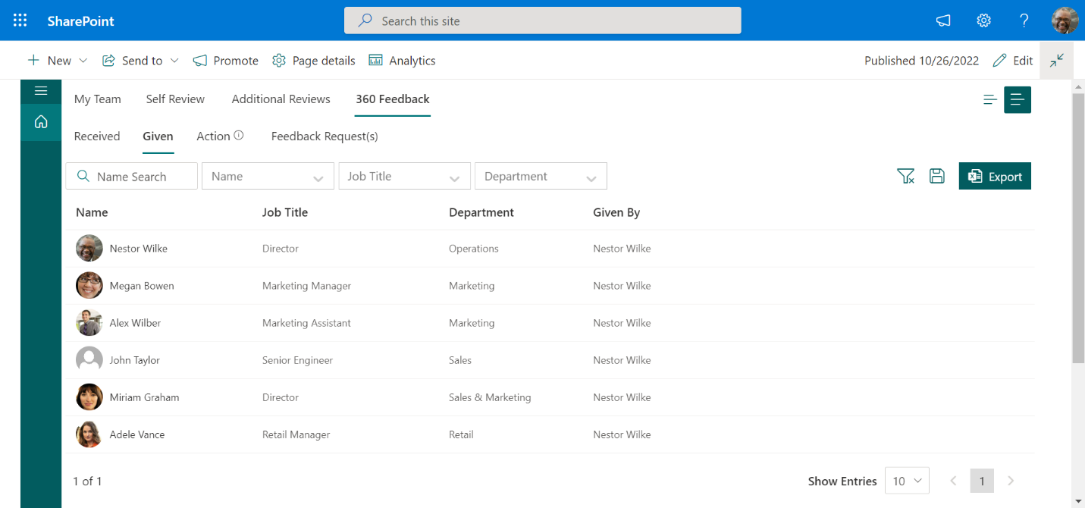

## **Action**

In action, the user can act on someone's feedback request. Here the user will be shown the details of the person who has requested the user for feedback. After clicking the edit icon user can act on the feedback request.

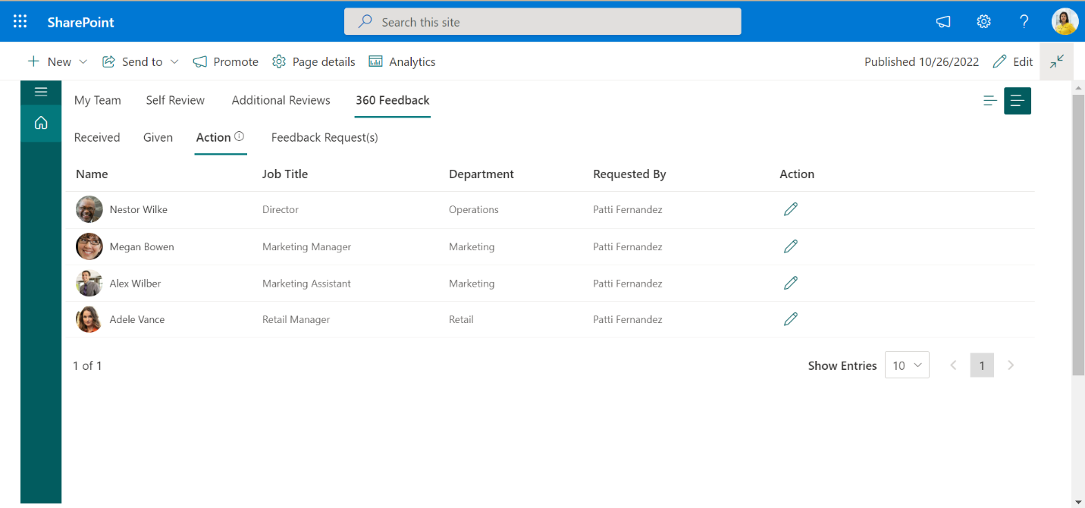

After clicking on the edit icon a given feedback panel will open in which the user will give feedback and submit that form after that his feedback-giving process will be finished as shown in the below image.

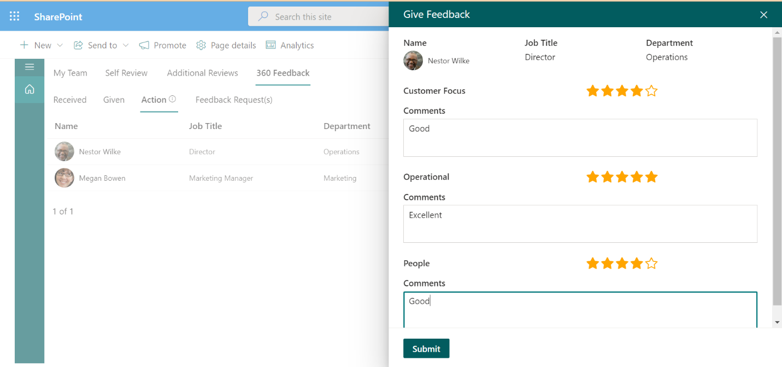

© 2025-[HR365.](https://www.hr365.us)[SLA.](https://www.hr365.us/sla/) [T&C.](https://www.hr365.us/terms-and-conditions) [EULA.](https://www.hr365.us/end-user-license-agreement-eula) [Privacy Policy.](https://www.cubiclogics.com/cubiclogics-india-pvt-ltd-terms-of-service-and-privacy-policy) [Cubic Logics.](https://www.cubiclogics.com)